Event API

API Details for events

Regan

2021

All of the below can also be achieved from the admin panel

# Create events

This is handled in the Django admin dashboard events can also be updated from here and images can be uploaded as well.

# View all events

ENDPOINT: localhost/api/events/

METHOD: get

REQUIRED INFORMATION: null

PURPOSE: returns json objects for all current events

EXPECTED RESPONSE:

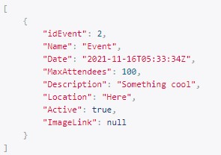

To consume this API, you just make a call to the endpoint

# Register

ENDPOINT: localhost/api/register/

METHOD: post

REQUIRED INFORMATION: Name, Email, Attendees, idEvent (this is currently hardcoded in models.py as default but will be implemented properly when the app is functioning)

PURPOSE: creates a record in the database to make a registration for a specific event

EXPECTED RESPONSE:



To consume this API, you are required to make a call to the endpoint with the properties of Name, Email, Attendees and idEvent

# View registrations

ENDPOINT: localhost/api/registrations/

METHOD: get

REQUIRED INFORMATION: null

PURPOSE: returns json objects of all persons registered for an event

EXPECTED RESPONSE:

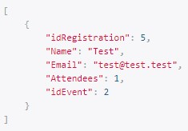

To consume this API, you just have to make a call to the endpoint

# Update registrations

ENDPOINT: localhost/api/update/

METHOD: post

REQUIRED INFORMATION: Name, Email, Attendees

PURPOSE: Updates a registered persons detail’s

EXPECTED RESPONSE:



To consume this API, make a call to the endpoint with the required properties (NOTE: this function requires that a persons email and name be present only once again this will be tweaked to use email and event id when this is functioning correctly)